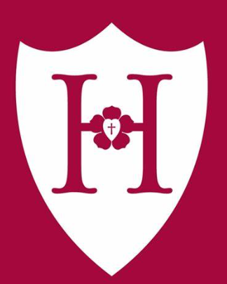 Sign your name, save a life!  Better Hope Hospital’s 7th Annual “Sign For Life” Gala  When  June 8th, 2025  4 pm – 8 pm  Where  Starling Reception Hall, Chesapeake, VA, 23320  Guest Speakers  - Kenzie Martin, Donor recipient  - Congressman Mike Dewitt  what to expect  - black-tie only  - Five-course dinner  - raffles  - silent auction  - guest speakers | Goal  sign up and Help us achieve our goal of 1,000 new donors!  admission  Tickets start at $100 per person, all proceeds go to United Networking for Organ Doning (UNOS)  Why?  The number of organ donors in the nation is severely lacking, more volunteers can save more lives.  additional information  For more information: speak to Heidi brooks, chairwoman of better Hope Hospital  Phone: (123) 456-7890  Email: h.brooks@gmail.com

